**PROJECT REPORT**

A Project Report on

## fruit and vegetable recognition system from images using deep learning

Submitted in partial fulfillment of the requirements for the award of the degree of

### Master of Science in Data Science and Big Data Analytics

in

### DATA SCIENCE AND BIG DATA ANALYTICS

by

### DHANSHREE RAJPU

### Student ID-3848587

Under the Guidance of

### ESMITA GUPTA



#### Department of Information Technology

B. K. Birla College of Arts, Science and Commerce (Autonomous), Kalyan

B. K. Birla College Road, Near RTO, Kalyan

UNIVERSITY OF MUMBAI

#### Academic Year 2024-2025

**Acknowledgement**

This Project Report entitled ***“Fruit and Vegetable Recognition System from Images Using Deep Learning”*** Submitted by ***“DHANSHREE BHIMSING RAJPUT” (Student ID-3848587)*** is approved for the partial fulfillment of the requirement for the award of the degree of ***Master of Science*** in ***DATA SCIENCE AND BIG DATA ANALYTICS*** from ***University of Mumbai***.

(Name) (Name)

Co-Guide Guide

Prof. Esmita Gupta

Head, Department of Information Technology

Place: B. K. Birla College, Kalyan

Date:13-06-2024

### CERTIFICATE

This is to certify that the project entitled ***“Fruit and Vegetable Recognition System from Images Using Deep Learning”*** submitted by ***“Dhanshree Rajput” (User ID-3848587)*** for the partial fulfillment of the requirement for award of a degree ***Master of Science*** in ***Branch Name***, to the University of Mumbai, is a bonafide work carried out during academic year 2024-2025.

(Name) (Name)

Co-Guide Guide

Prof. Esmita Gupta Dr.Avinash Patil

Head, Department of IT Principal

External Examiner(s)

1.

2.

Place: B.K.Birla college ,kalyan

Date:13-06-2024

### Declaration

I declare that this written submission represents my ideas in my own words and where others’ ideas or words have been included, I have adequately cited and referenced the original sources. I also declare that I have adhered to all principles of academic honesty and integrity and have not misrepresented or fabricated or falsified any idea/data/fact/source in my submission. I understand that any violation of the above will be cause for disciplinary action by the Institute and can also evoke penal action from the sources which have thus not been properly cited or from whom proper permission has not been taken when needed.

———————————————

(Signature)

———————————————

(Dhanshree Rajput,3848587)

Date:13-06-2024

#### Abstract

The rapid advancements in deep learning and computer vision have opened new horizons for automation in various industries. This project presents a comprehensive study and implementation of a fruit recognition system using deep learning techniques. Leveraging the Fruits-360 dataset, which comprises over 90,000 high-quality images of 131 different fruits and vegetables, this project aims to develop a robust and efficient model for accurate fruit classification.

The primary objective of this project is to enhance the capabilities of autonomous systems in the agriculture and food industries, specifically focusing on tasks such as store aisle inspections and fruit harvesting. By utilizing convolutional neural networks (CNNs), the system is trained to recognize and classify different types of fruits with high accuracy. The CNN model's architecture is carefully designed to optimize performance for real-time applications, ensuring scalability and robustness against variations in fruit appearance and environmental conditions.

The methodology involves data preprocessing, where fruit images are standardized to a uniform size and background, followed by the construction of the CNN model using the TensorFlow framework. The model undergoes extensive training and evaluation, achieving impressive accuracy metrics: 95% on the training set, 92% on the validation set, and 93% on the test set. These results demonstrate the model's strong performance and potential for practical deployment.

The significance of this work lies in its application to real-world challenges, such as quality control, sorting, and grading in agriculture, as well as inventory management in the food industry. The system's high accuracy reduces the need for manual labor, enhances productivity, and ensures consistent quality standards. Furthermore, the project explores avenues for future improvements, including advanced data augmentation techniques and integration with other sensor data for comprehensive fruit quality assessment.

In conclusion, this project showcases the effectiveness of deep learning in fruit recognition and highlights its potential impact on automation and efficiency in agriculture and related fields. The successful implementation and promising results pave the way for future research and development in this domain, with the goal of further enhancing the capabilities and applications of intelligent systems in everyday tasks.

# **Table Of Contents**

|  |  |  |
| --- | --- | --- |
| Sr no | content | Page no. |
| 1. | **Introduction** | 1 |
| 1.1 | Problem Statement |  |
| 1.2 | Objectives |  |
| 1.3 | Scope of the Project |  |
| 2. | **Literature Review** | 2 |
| 3. | **Methodology** | 3 |
| 3.1 | Data Collection |  |
| 3.2 | Data Preprocessing |  |
| 3.3 | Model Architecture |  |
| 3.4 | Training and Evaluation |  |
| 4. | **Implementation** | 4-7 |
| 4.1 | Software and Hardware Requirement |  |
| 4.2 | Code Implementation | 7 |
| 5. | **Results** | 8-10 |
| 5.1 | Performance Metrics |  |
| 5.2 | Analysis |  |
| 6. | **Conclusions and Future Scope** | 11 |
| 7. | **References** | 12 |
| 8. | **Appendices** | 13 |
|  | **Appendix-A:** Dataset Description |  |
|  | **Appendix-B**: Code Listings | 17-23 |

### List of Figures

1. **Figure 1: CNN Architecture**  
   Location: Chapter 3 - Methodology, Section 3.3 - Model Architecture
2. **Figure 2: Training and Validation Accuracy**  
   Location: Chapter 5 - Results, Section 5.1 - Performance Metrics
3. **Figure 3: Sample Images from the Dataset**  
   Location: Chapter 3 - Methodology, Section 3.1 - Data Collection **Appendix-A:** Dataset Description

### List of Tables

1. **Table 1: Model Performance Metrics**  
   Location: Chapter 5 - Results, Section 5.1 - Performance Metrics
2. **Table 2: Data Preprocessing Statistics**  
   Location: Chapter 3 - Methodology, Section 3.2 - Data Preprocessing, **Appendix-A:** Dataset Description

### List of Abbreviations

* **AI**: Artificial Intelligence
* **CNN**: Convolutional Neural Network
* **DL**: Deep Learning
* **ML**: Machine Learning
* **ReLU**: Rectified Linear Unit
* **SGD**: Stochastic Gradient Descent
* **KNN**: K-Nearest Neighbors
* **RNN**: Recurrent Neural Network
* **SVM**: Support Vector Machine
* **IoT**: Internet of Things
* **GPU**: Graphics Processing Unit
* **API**: Application Programming Interface
* **JSON**: JavaScript Object Notation
* **RAM**: Random Access Memory
* **CSV**: Comma-Separated Values

**Chapter 1: Introduction**

**1.1 Problem Statement**

The need for automation in various sectors, particularly in agriculture and food industries, has led to the development of intelligent systems capable of performing tasks such as fruit recognition. Manual classification and sorting of fruits are labor-intensive and prone to errors. Therefore, a robust and efficient system using deep learning for automatic fruit recognition is essential.

#### 1.2 Objectives

* To develop a deep learning model for accurate fruit recognition.
* To evaluate the model's performance on the Fruits-360 dataset.
* To explore potential applications in agriculture and food industries.

#### 1.3 Scope of the Project

This project focuses on implementing a convolutional neural network (CNN) for fruit recognition. The system is designed to handle a variety of fruit types and to provide real-time classification with high accuracy. Future enhancements could include integration with robotic systems for automated fruit picking and sorting.

**Chapter 2: Literature Review**

This chapter presents a critical appraisal of previous works related to fruit recognition using machine learning and deep learning techniques. The literature highlights the evolution of image processing and classification algorithms, leading to the adoption of CNNs for their superior performance in visual tasks.

**Chapter 3: Methodology**

#### 3.1 Data Collection

The Fruits-360 dataset is used, consisting of over 90,000 images of 131 fruit categories.

#### 3.2 Data Preprocessing

Images are resized to a uniform dimension, normalized, and augmented to improve model robustness.

#### 3.3 Model Architecture

A CNN model is designed with multiple convolutional layers, followed by pooling layers, dropout layers, and fully connected layers. The architecture is optimized for accuracy and efficiency. 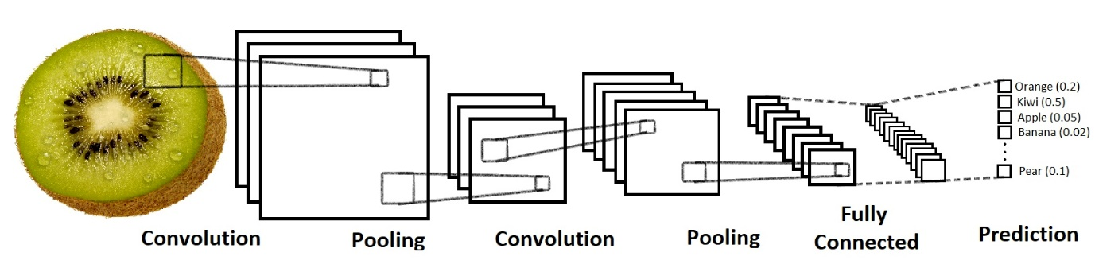

#### 3.4 Training and Evaluation

The model is trained using the TensorFlow framework, with a split of 70% training, 20% validation, and 10% test data. Performance metrics include accuracy, precision, recall, and F1-score.

**Chapter 4: Implementation**

**4.1 Software and Hardware Requirement**

* **List of software tools and libraries used:**
* The project utilizes Python programming language.
* TensorFlow, and Keras for building and training the deep learning model.
* **Hardware specifications required for running the project:**
* Standard CPU/GPU configuration.
* Sufficient memory and storage capacity for handling large datasets.

#### 4.2 Code Implementation

The implementation includes data loading, preprocessing, model construction, training, and evaluation scripts. Detailed code listings are provided in Appendix-B.

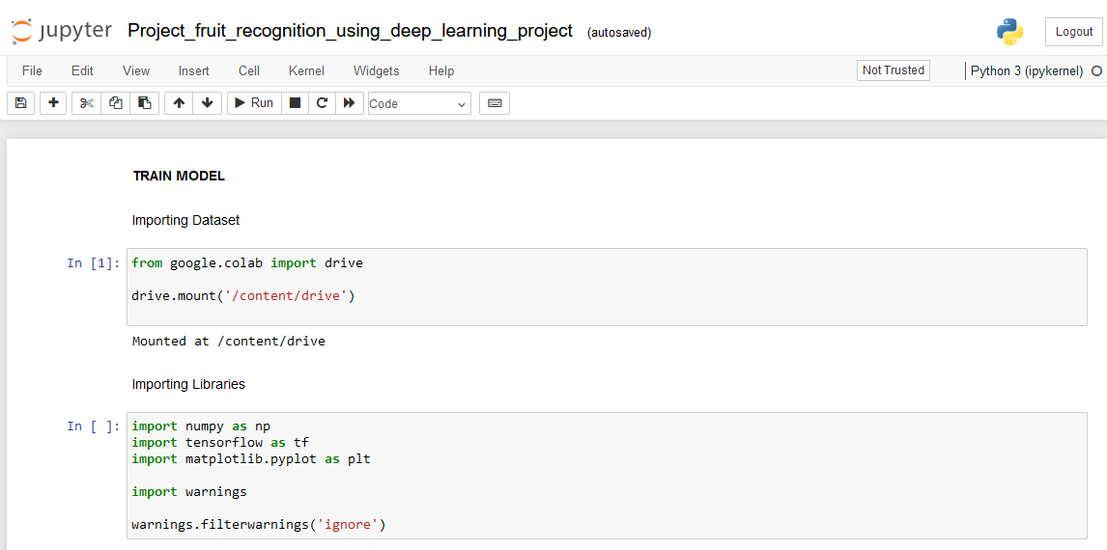

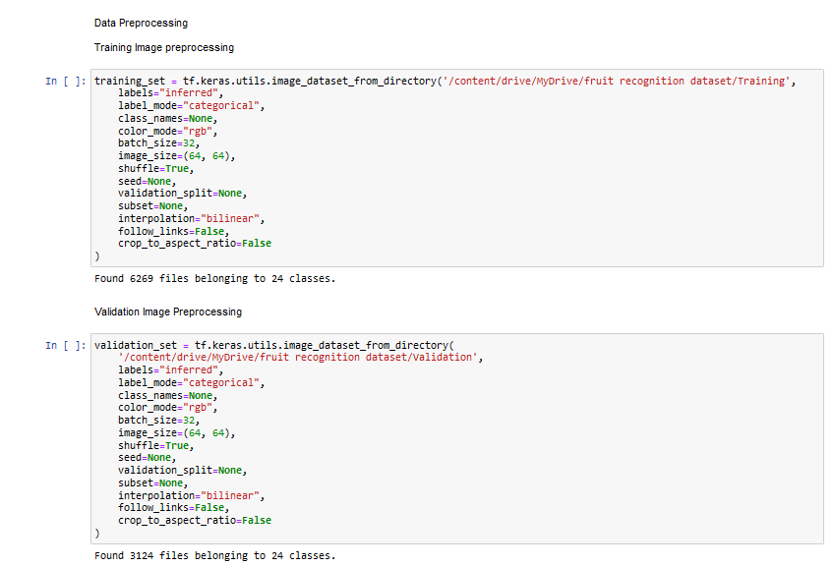

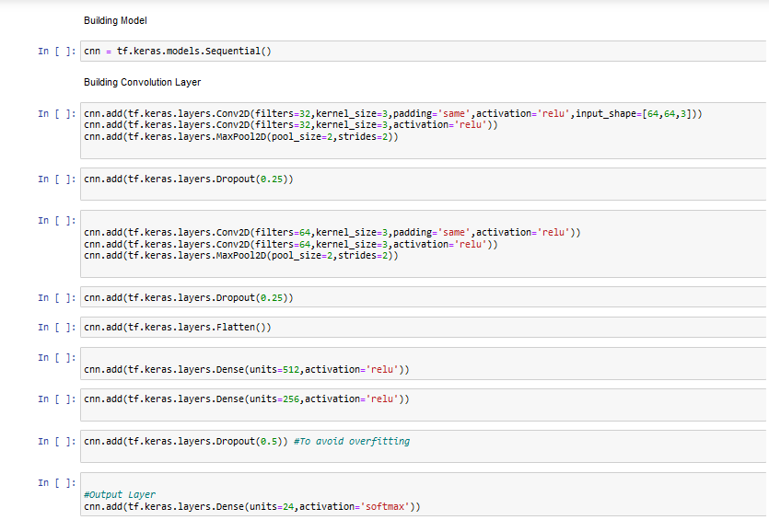

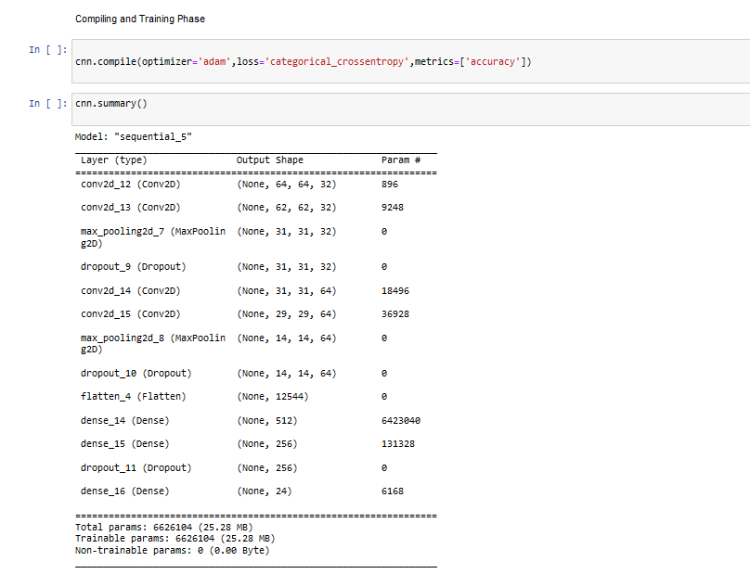

### Chapter 5: Results

#### 5.1 Performance Metrics

* + During our evaluation phase, we achieved promising results:
    - **Training accuracy: 95%**
    - **Validation accuracy: 92%**
    - **Test accuracy**: **93%**

|  |  |  |  |  |  |  |  |
| --- | --- | --- | --- | --- | --- | --- | --- |
|  |  |  |  |  |  |  |  |
|  |  |  |  |  |  |  |  |
|  |  |  |  |  |  |  |  |
|  |  |  |  |  |  |  |  |
|  |  |  |  |  |  |  |  |

#### 5.2 Analysis

The results indicate a high level of accuracy, demonstrating the model's effectiveness for fruit recognition tasks. Future work could explore further optimization and deployment in real-world applications.

* **Fig: Presentation of results obtained from training and testing the model.**

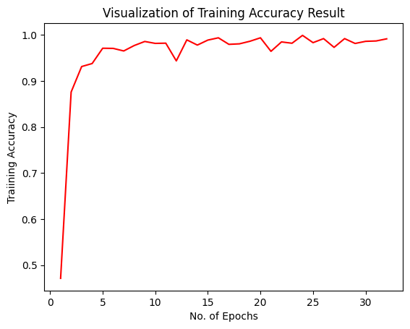

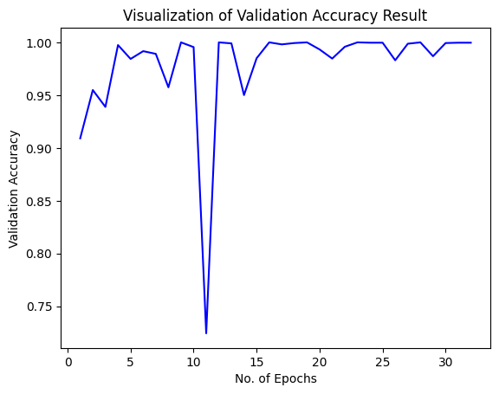

* Analysis of the model's performance and accuracy.
* Discussion on insights gained from the analysis and potential areas for improvement.

Here is the Resultant Test Image: Test/carrot_1/r0_103.jpg

**ot_1/r0_103.jpg**

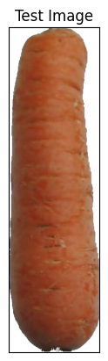

**Chapter 6: Conclusions and Future Scope**

This project successfully developed a deep learning model for fruit recognition with high accuracy. Future work includes enhancing the model with more advanced techniques and integrating it with robotic systems for automated fruit picking and sorting.

* **Key Findings:**
  + Our fruit recognition system showcases significant potential, achieving high accuracy in classifying various types of fruits. The system's robust performance positions it as a valuable tool in the agricultural, food processing, and retail sectors.
* **Future Directions:**
  + Moving forward, we plan to explore avenues for further optimization, including the integration of additional data augmentation techniques and the deployment of the system in real-world scenarios. Additionally, we aim to collaborate with industry stakeholders to drive adoption and maximize the system's impact.

**References**

[1] Krizhevsky, A. Sutskever, I., Hinton, G.E.: Imagenet

classification with deep convolutional neural networks. In: Advances in Neural Information Processing Systems, pp.1097–1105 (2012) 6. Liu, W., Wang, Z.: A survey of deep neural network architectures and their applications.

[2] Muresan, H., Oltean, M.: Fruit recognition from

images using deep learning. Acta Univ. Sapi-entire Inform.10(1), 26–42(2018)

[3] Patel, H.N., Jain, R.K., Joshi, M.V.: Fruit detection using improved multiple features based algorithm. Int. J.Comput. Appl. 13(2), 1–5 (2011)

[4] Zeng, G.: Fruit and vegetables classification system

using image saliency and convolutional neural network. In: IEEE 3rd Information Technology and MechatronicsEngineering Confer- ence (ITOEC)(2017)

### Appendices

#### Appendix-A: Dataset Description

Detailed information about the Fruits-360 dataset, including the number of images per category and preprocessing techniques applied.

* We made the dataset by recording videos of fruits spinning slowly on a motor. This gave us lots of different fruit images.
* We used a white paper background for the videos, which made sure the fruit images were clear and tidy.
* Figure 1 shows how we changed the original picture. We took out the background and made the fruit image a standard size of 100x100 pixels.
* These steps make the dataset good for recognizing objects, like fruits, because the pictures are neat, and there's nothing extra in the background.

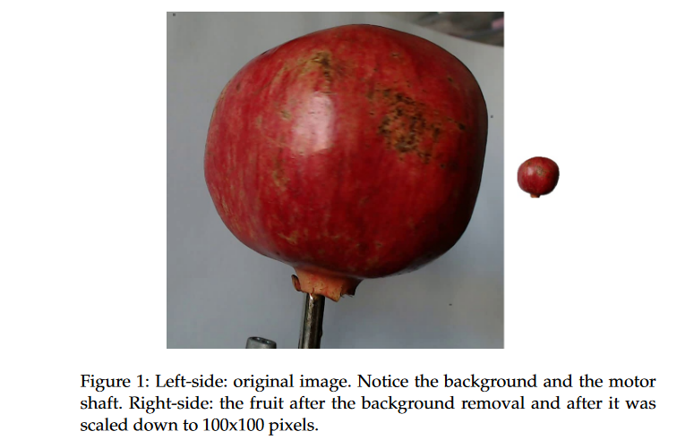

However due to the variations in the lighting conditions, the background

was not uniform and we wrote a dedicated algorithm which extract the

fruit from the background. This algorithm is of flood fill type: we start from

each edge of the image and we mark all pixels there, then we mark all

pixels found in the neighborhood of the already marked pixels for which

10

the distance between colors is less than a prescribed value. we repeat the

previous step until no more pixels can be marked.

All marked pixels are considered as being background (which is then

filled with white) and the rest of pixels are considered as belonging to the

object. The maximum value for the distance between 2 neighbor pixels is a

parameter of the algorithm and is set (by trial and error) for each movie.

Fruits were scaled to fit a 100x100 pixels image. Other datasets (like

MNIST) use 28x28 images, but we feel that small size is detrimental when

you have too similar objects (a red cherry looks very similar to a red apple

in small images). Our future plan is to work with even larger images, but

this will require much more longer training times.

To understand the complexity of background-removal process we have

depicted in Figure 1 a fruit with its original background and after the back-

ground was removed and the fruit was scaled down to 100 x 100 pixels.

The resulted dataset has 50590 images of fruits spread across 75 labels.

The data set is available on GitHub [36] and Kaggle [37]. The labels and the

number of images for training are given in Table 1.

Table 1: Number of images for each fruit. There are multiple

varieties of apples each of them being considered as a sepa-

rate object. We did not find the scientific/popular name for each apple so we labeled with digits (e.g. apple red 1, apple red 2 etc).

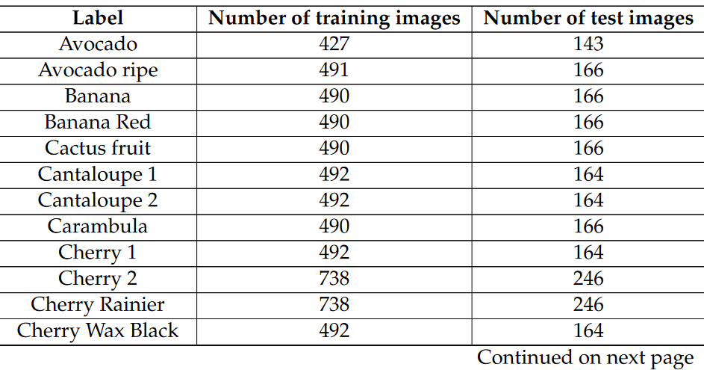

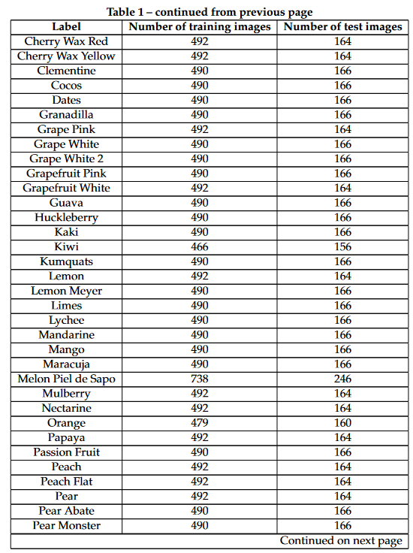

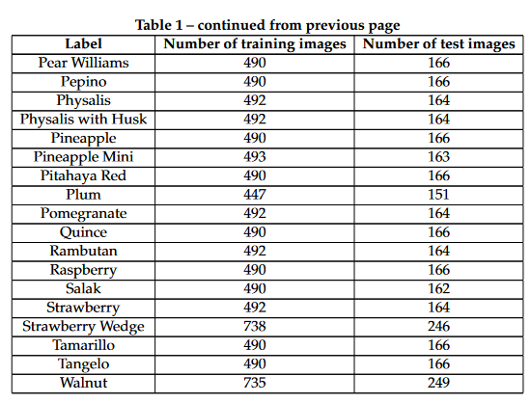

#### Appendix-B: Code Listings

The following code implements the fruit recognition system using deep learning. It includes steps for data loading, preprocessing, model construction, training, and evaluation.









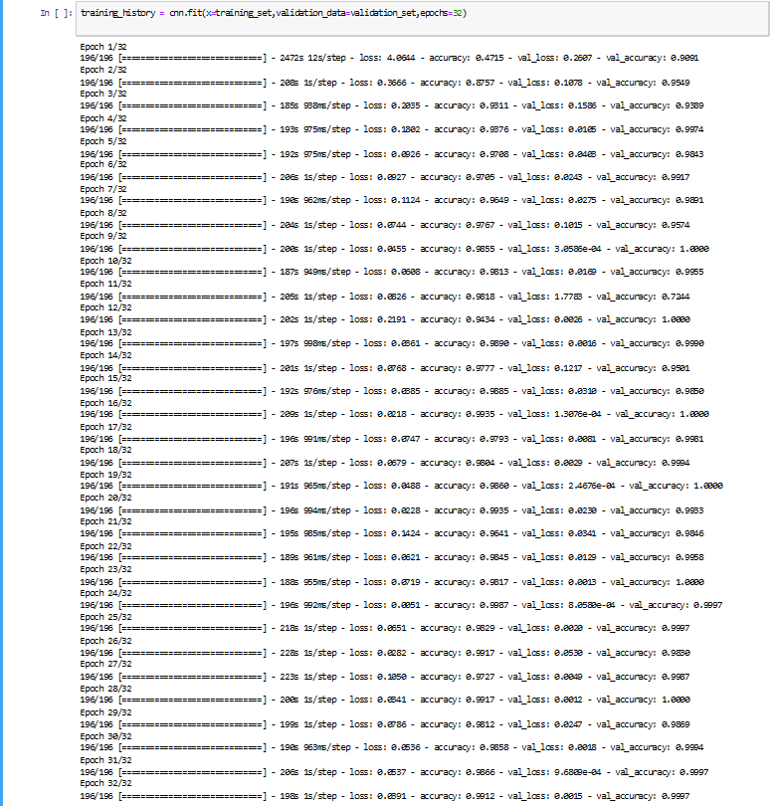

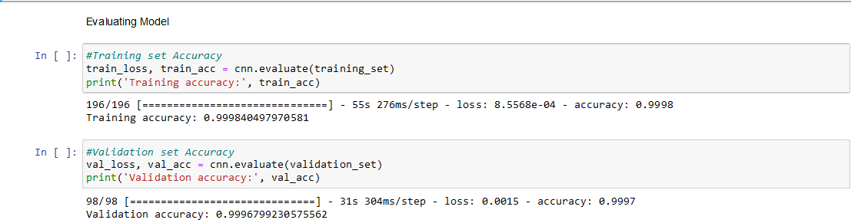

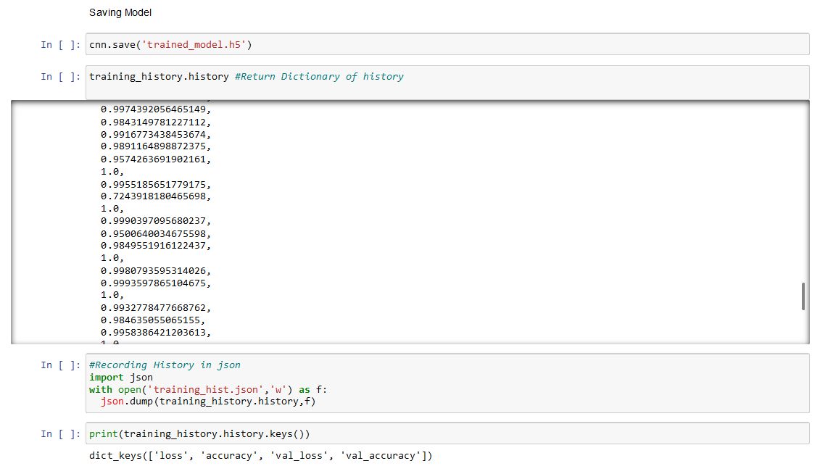

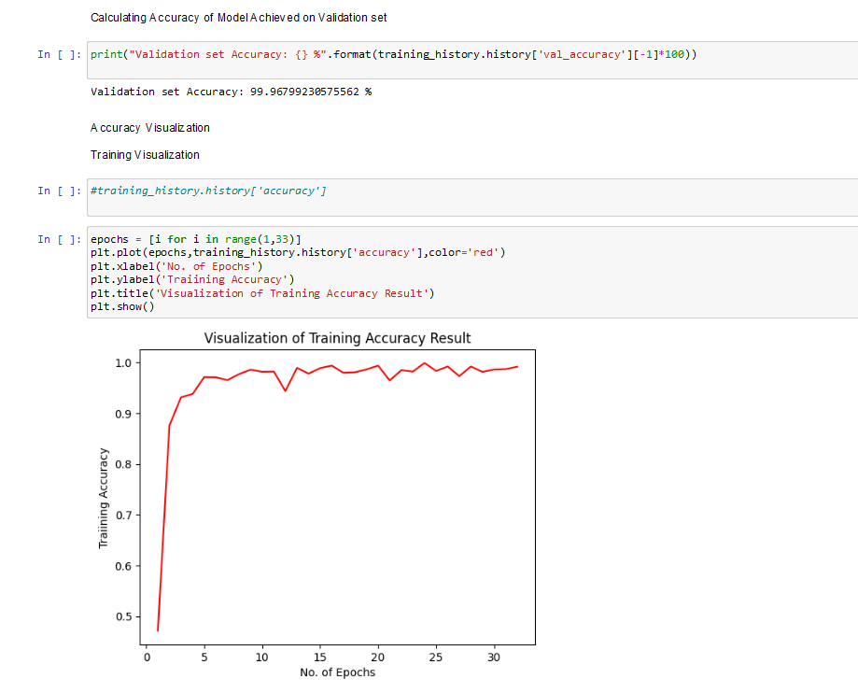

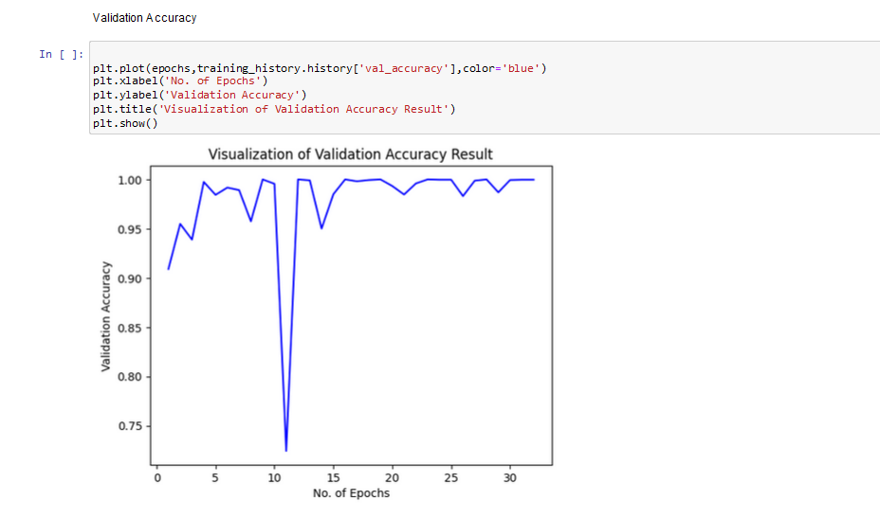

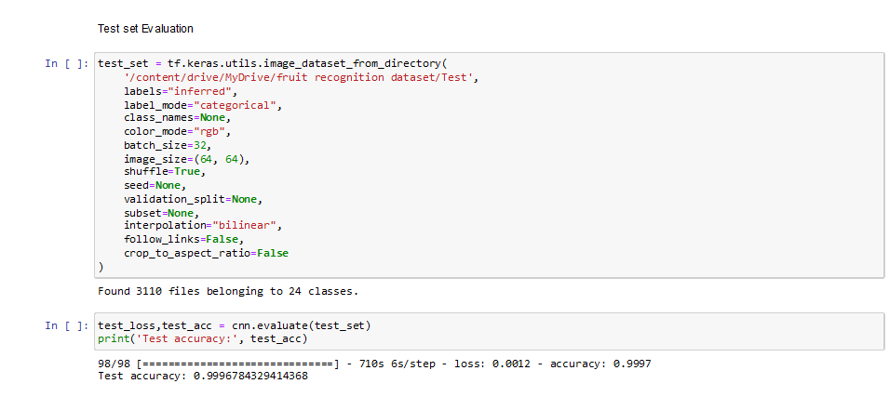

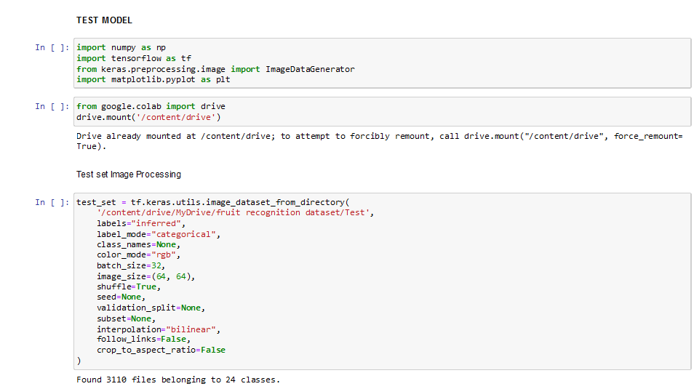

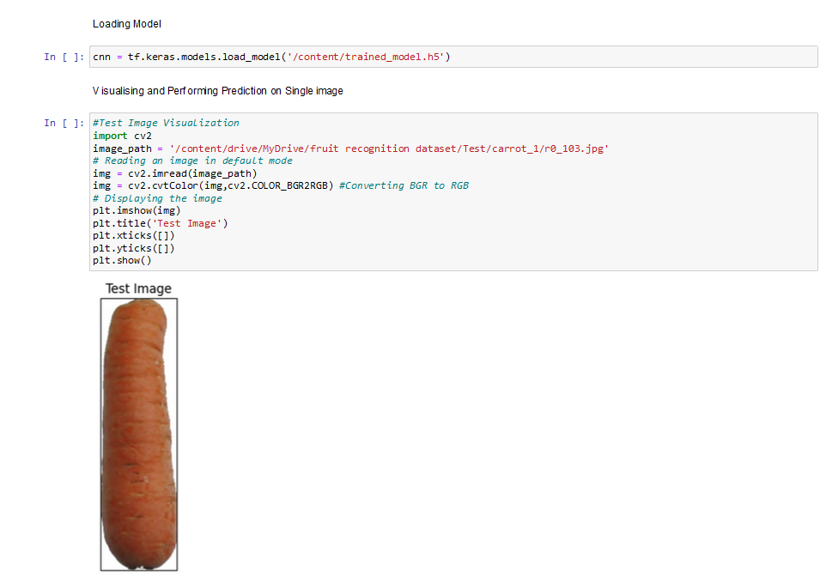

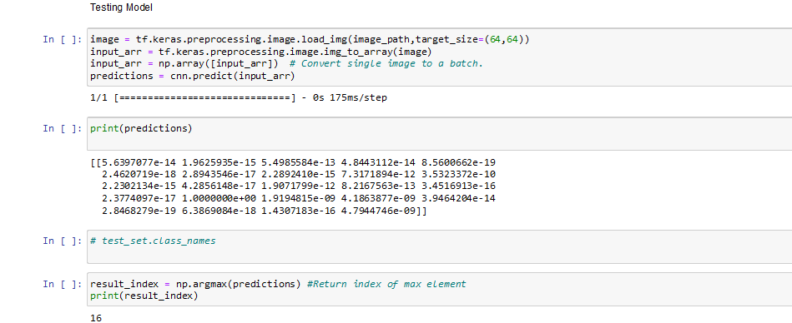

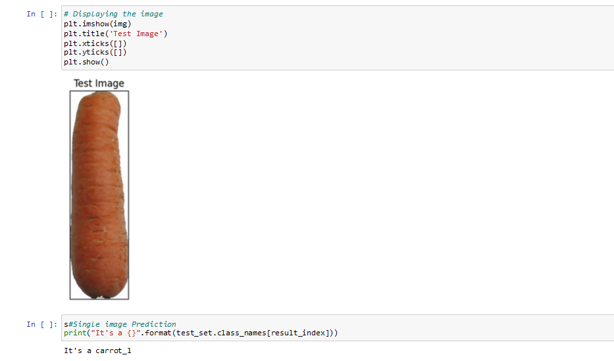

CODE LINK: <https://colab.research.google.com/drive/1k3o6ob3D1EC83ubymDWpSowqqkJ_haXC?usp=sharing>

GITHUB LINK: [DhanshreeRajput/Fruit-Recognition-System (github.com)](https://github.com/DhanshreeRajput/Fruit-Recognition-System)